WADS LAB [30 Jan 2025]

HU22CSEN0100287

Sai Ganesh Eswaraprasad

1. Js program to convert objects to strings

CODE:

<!DOCTYPE html>

<html lang="en">

<head>

<meta charset="UTF-8">

<meta name="viewport" content="width=device-width, initial-scale=1.0">

<title>Object to String Converter</title>

</head>

<body>

<h1>Object to String Conversion</h1>

<p id="result"></p>

<script>

let obj = { name: "Alice", age: 25 };

let str = JSON.stringify(obj);

document.getElementById("result").innerText = str;

</script>

</body>

</html>

1. Converting js object to JSON

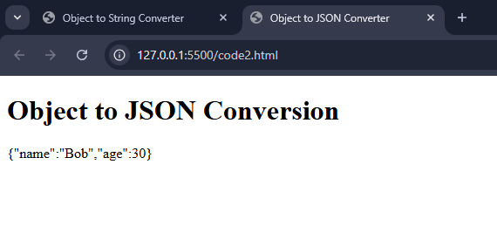

CODE:

<!DOCTYPE html>

<html lang="en">

<head>

<meta charset="UTF-8">

<meta name="viewport" content="width=device-width, initial-scale=1.0">

<title>Object to JSON Converter</title>

</head>

<body>

<h1>Object to JSON Conversion</h1>

<p id="json-result"></p>

<script>

let obj = { name: "Bob", age: 30 };

let json = JSON.stringify(obj);

// Display the JSON result in the HTML

document.getElementById("json-result").innerText = json;

</script>

</body>

</html>

1. Fetch product details

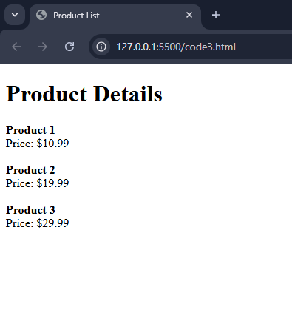

CODE:

[products.json]

[

{ "id": 1, "name": "Product 1", "price": 10.99 },

{ "id": 2, "name": "Product 2", "price": 19.99 },

{ "id": 3, "name": "Product 3", "price": 29.99 }

[code3.html]

<!DOCTYPE html>

<html lang="en">

<head>

<title>Product List</title>

</head>

<body>

<h1>Product Details</h1>

<div id="product-list"></div>

<script>

fetch('products.json')

.then(response => response.json())

.then(products => {

let productList = document.getElementById('product-list');

products.forEach(product => {

let productItem = document.createElement('div');

productItem.innerHTML = `<strong>${product.name}</strong><br>Price: $${product.price}<br><br>`;

productList.appendChild(productItem);

});

})

.catch(error => console.error('Error fetching product data:', error));

</script>

</body>

</html>

1. Record Expenses

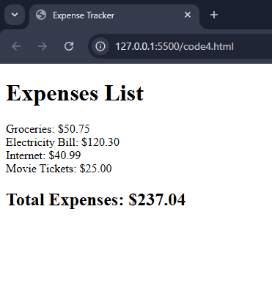

CODE:

[expenses.json]

[

{ "item": "Groceries", "amount": 50.75 },

{ "item": "Electricity Bill", "amount": 120.30 },

{ "item": "Internet", "amount": 40.99 },

{ "item": "Movie Tickets", "amount": 25.00 }

]

[code4.html]

<!DOCTYPE html>

<html lang="en">

<head>

<meta charset="UTF-8">

<meta name="viewport" content="width=device-width, initial-scale=1.0">

<title>Expense Tracker</title>

</head>

<body>

<h1>Expenses List</h1>

<div id="expense-list"></div>

<h2>Total Expenses: $<span id="total-expenses">0.00</span></h2>

<script>

fetch('expenses.json')

.then(response => response.json())

.then(expenses => {

let expenseList = document.getElementById('expense-list');

let total = 0;

expenses.forEach(expense => {

let expenseItem = document.createElement('div');

expenseItem.innerHTML = `${expense.item}: $${expense.amount.toFixed(2)}`;

expenseList.appendChild(expenseItem);

total += expense.amount;

});

document.getElementById('total-expenses').innerText = total.toFixed(2);

})

.catch(error => console.error('Error fetching expenses data:', error));

</script>

</body>

</html>